Title (Heading 1: Arial 18pt)
Author’s Last Name, Author’s First Name*ª; Second Author’s Last Name, Second Author’s First Name^{b}; Third Author’s Last Name, Third Author’s First Name^{b} (Authors: Calibri 10pt)
ª Affiliation Organisation Name, City, Country (Affiliation: Calibri 9pt)
^{b} Affiliation Organisation Name, City, Country
* The corresponding author e-mail address
This guide provides instructions to submit a workshop proposal for the IASDR 2023 congress hosted by the Politecnico di Milano. Please format your workshop proposal exactly as this document is formatted. To reduce your time formatting your submission, you can substitute the content of this template with your own. You can easily find the text styling of this template by searching the embedded styles that contain 'IASDR' in their naming. The workshop proposal should be 2000-2500 words long, excluding the abstract and references. The abstract should be up to 250 words and should not contain quotations and references. Submit the workshop proposal to https://iasdr2023.polimi.it for review. (Abstract: Calibri 10pt)
Keywords: formatting instruction; template; workshop; IASDR (maximum 4 keywords, separate each keyword with a semicolon) (Keywords: Calibri bold italic 10pt)
- Workshop description (Heading 2: Calibri bold 14pt)
IASDR 2023 workshops present the opportunity to participants of building crossovers and connections between research and practice and probe topics and issues. We invite proposals that, within the nine congress’ sub-themes, explore concepts, theories, processes, frameworks, practices, and pragmatics through a long format (either 3 or 6 hours).
Applicants wishing to submit a workshop proposal must write a 2000-2500-word proposal, excluding the abstract and references. The workshop proposal should follow this template and include the topic background, thematic link, workshop aim, employed methods, expected outcome, and the prior experience of each workshop organizer in the bio section at the bottom of the template. Please, also include a brief workshop schedule and your expected participant profile and numbers.
Workshop proposals will not be part of the proceedings; however, we will publish them on the congress website before its start. A review panel from the Politecnico di Milano will review and select all workshop submissions. After the review period, we will notify all authors of acceptance or rejection via email.
After holding the workshop, we require the workshop organizer(s) to provide a report of the results including workshop photographs. We will publish this report on the IASDR website.
Use this section to briefly outline the topic background, the thematic link to one of the congress’ nine sub-themes, and the workshop aim.
- Session set-up
This section should carefully explain the proposed format and activities, detailing the plan and schedule, the expected participant profile and numbers, the strategy to document contributions, and the expected results. This section can be organized in tables and/or paragraphs and can include images or diagrams (see section 4 for formatting guidelines). Finally, describe the different roles played by the organizers.
- Requirements
Please, list all the main requirements of your proposal. Include the type of space needed for a successful session and list specifics (e.g., tables, chairs, materials, laptops, projectors, etc.). We will provide venues and materials but request for authors to include their specific requirements.
- Formatting your workshop submission
To reduce your time formatting your submission, you can substitute the content of this template with your own. You can easily find the text styling of this document by searching the embedded styles that contain 'IASDR' in their naming in the Styles Pane.
The page is an A4 (21cm x 29.7cm) set with a top margin of 2.54 cm, a bottom margin of 2.54 cm, a left margin of 2.54 cm, and a right margin of 2.54 cm.
Please use footnotes instead of endnotes and never use footnotes as a reference list.
- Headings (Heading 3: Calibri bold 12pt)
You can find the Heading styles of this document under the names ‘IASDR Heading 1’, ‘IASDR Heading 2’, ‘IADSR Heading 3’, and ‘IADSR Subheading’. Always add text below the headings (never leave headings under headings).
- Subheadings (Subheading: Calibri 11pt)
If you require another heading level, use the ‘IASDR Subheading’ style. This subheading style has the same styling as that of the document’s text (‘IASDR Main text’).
- Title and authors
Workshop proposal titles should have a maximum length of two rows. The workshop organizers should be listed as authors of the workshop proposal.
- Language and style
English is the writing language of the congress. When writing, try using gender-neutral language and avoid difficult technical terms. Before using acronyms for the first time, write the full name.
- Lists
For sequential listings with numbers, use the ‘IASDR Numbered List’ style. For example:
- List item 1 (Numbered list: Calibri 11pt)
- List item 2
- List item 3
For non-sequential listings in bullet points, use the ‘IASDR Bullet List’ style. For example:
- Bullet point 1 (Bullet list: Calibri 11pt)
- Bullet point 2
- Bullet point 3
- Images
Images and figures should have a resolution that supports print and online viewing. We recommend a resolution of 300 ppi and a minimum resolution of 150 ppi. Always place images/figures within the main text body and apply the ‘IASDR Caption’ style to the captions. Images/figures and captions should always align to the left margin and never exceed the column width. Number images/figures sequentially, starting with Figure 1. See Figure 1 for an example.
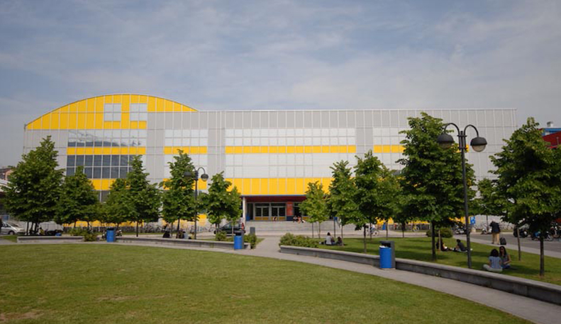
Figure 1. Design campus of the Politecnico di Milano. Source: Polimi Events. (Caption: Calibri italic 9pt)
Captions for the figures should clearly explain what the image illustrates concerning the text. If there are two or more images side-by-side, as shown in Figure 2, you should combine the figures into a single image using image editing software (e.g., Adobe Photoshop) before placing them in the text.
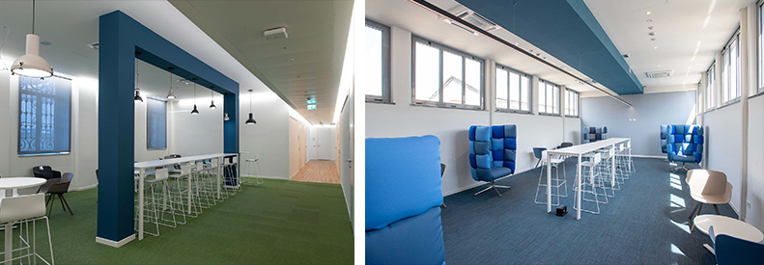
Figure 2. Shared workspaces at the Department of Design of Politecnico di Milano. Source: Department of Design.
We welcome the authors to use colour images.
- Tables
Use Word’s table feature to create tables and format them as Table 1. If possible, left-align the text of all columns. Number tables sequentially, starting with Table 1.
See Table 1 for an example.
(Table text: Calibri 10pt) | Column 2 | Column 3 | Column 4
Second Row | Cell one | Cell four | Cell seven
Third Row | Cell two | Cell five | Cell eight
Fourth Row | Cell three | Cell six | Cell nine
Table 1. This is an example of a table that adapts from an external source
If the table is from an external source, indicate the original reference below the table using ‘IADSR Caption’; if the table presents an original work, please insert one empty line below the table by using ‘IASDR Caption’, as shown in Table 2.
Table 2. This is an example of the formatting of an original table (Table title: Calibri 10pt)
(Table text: Calibri 10pt) | Column 2 | Column 3 | Column 4
Second Row | Cell one | Cell four | Cell seven
Third Row | Cell two | Cell five | Cell eight
Fourth Row | Cell three | Cell six | Cell nine

- Referencing
Please follow the APA reference style for the workshop proposal. For more details, please refer to lessons 16-19 of “Basics of Seventh Edition APA Style.” To format the reference list, use the ‘IASDR Reference’ style. Where possible, include DOI.
Place citations that do not form part of a sentence inside parenthesis. For example: (Jackson, 2019). Show the author(s) name in text and the year within parenthesis for citations that are part of a sentence. For example: Jackson (2019) argues that…
When citing multiple works by the same author(s), separate the publication years with commas. When citing works by different authors in one parenthesis, separate them by semicolons and place them in alphabetical order. For example: (Dillard, 2020; Jackson, 2019).
Give both names when a reference is authored by one or two individuals. For example: (Kushilevitz & Malkin, 2016). For three or more authors, name only the first one followed by et al.. For example: (Duckworth et al., 2019).

References
Examples of references (taken from APA Style):
Journal article with a DOI:
Grady, J. S., Her, M., Moreno, G., Perez, C., & Yelinek, J. (2019). Emotions in storybooks: A comparison of storybooks that represent ethnic and racial groups in the United States. Psychology of Popular Media Culture, 8(3), 207–217. https://doi.org/10.1037/ppm0000185 (Reference list: Calibri 10pt)

Conference proceedings published in a journal:
Duckworth, A. L., Quirk, A., Gallop, R., Hoyle, R. H., Kelly, D. R., & Matthews, M. D. (2019). Cognitive and noncognitive predictors of success. Proceedings of the National Academy of Sciences, USA, 116(47), 23499–23504. https://doi.org/10.1073/pnas.1910510116

Conference proceedings published as a whole book:
Kushilevitz, E., & Malkin, T. (Eds.). (2016). Lecture notes in computer science: Vol. 9562. Theory of cryptography. Springer. https://doi.org/10.1007/978-3-662-49096-9

Conference proceedings published as a book chapter:
Bedenel, A.-L., Jourdan, L., & Biernacki, C. (2019). Probability estimation by an adapted genetic algorithm in web insurance. In R. Battiti, M. Brunato, I. Kotsireas, & P. Pardalos (Eds.), Lecture notes in computer science: Vol. 11353. Learning and intelligent optimization (pp. 225–240). Springer. https://doi.org/10.1007/978-3-030-05348-2_21

Book:
Jackson, L. M. (2019). The psychology of prejudice: From attitudes to social action (2nd ed.). American Psychological Association. https://doi.org/10.1037/0000168-000
Sapolsky, R. M. (2017). Behave: The biology of humans at our best and worst. Penguin Books.
Svendsen, S., & Løber, L. (2020). The big picture/Academic writing: The one-hour guide (3rd digital ed.). Hans Reitzel Forlag. https://thebigpicture-academicwriting.digi.hansreitzel.dk/

Chapter in a book:
Aron, L., Botella, M., & Lubart, T. (2019). Culinary arts: Talent and their development. In R. F. Subotnik, P. Olszewski-Kubilius, & F. C. Worrell (Eds.), The psychology of high performance: Developing human potential into domain-specific talent (pp. 345–359). American Psychological Association. https://doi.org/10.1037/0000120-016
Dillard, J. P. (2020). Currents in the study of persuasion. In M. B. Oliver, A. A. Raney, & J. Bryant (Eds.), Media effects: Advances in theory and research (4th ed., pp. 115–129). Routledge.
Thestrup, K. (2010). To transform, to communicate, to play—The experimenting community in action. In E. Hygum & P. M. Pedersen (Eds.), Early childhood education: Values and practices in Denmark. Hans Reitzels Forlag. https://earlychildhoodeducation.digi.hansreitzel.dk/?id=192
About the Authors: (Author bio title: Calibri bold 10pt)
Organizer’s name: Describe the prior experience of the workshop organizer in a maximum limit of 40 words. (Author bio text: Calibri 10pt)
Organizer’s name: Describe the prior experience of the workshop organizer in a maximum limit of 40 words.
Organizer’s name: Describe the prior experience of the workshop organizer in a maximum limit of 40 words.

