Title (Heading 1: Arial 18pt)
Author’s Last Name, Author’s First Name*ª; Second Author’s Last Name, Second Author’s First Name^{b}; Third Author’s Last Name, Third Author’s First Name^{b} (Authors: Calibri 10pt)
ª Affiliation Organisation Name, City, Country (Affiliation: Calibri 9pt)
^{b} Affiliation Organisation Name, City, Country
* The corresponding author e-mail address
- Introduction (Heading 2: Calibri bold 14pt)
We invite experts to submit a panel proposal to IASDR 2023. Panels provide unique opportunities for participants and experts to discuss novel research areas, directions, methods, policies, and opinions in the themes relevant to the congress. Since panel presentation is not the same as paper presentation or short talks it does not require to present original research.
Within the nine congress sub-themes, we strongly encourage panelists to build around topics attractive to the public. Proposing controversial ideas and including experts with different schools of thought is also appreciated. We require for panelists to be experts in their field and be able to creatively engage other panel members and the audience in discussion. In their proposal, panel members may include experts with different school of thoughts and even controversial ideas for discussion.
Panel proposals should be within 1000 words long, excluding references and panel member bios. The proposal should include:
- Topic background
- Thematic link – how the topic is linked to the nine congress sub-themes available on the congress website (https://www.iasdr2023.polimi.it/theme-and-tracks/)
- Aim of the panel
- Possible discussion points
- Short bio of each panel member (50 – 75 words per panel member) following the format at the end of this template
As part of the congress programme, each panel will be allotted a 1.5-hour slot.
Please, see section 2 for panel proposal formatting details. (Main text: Calibri 11pt)
- Formatting your panel submission
To reduce your time formatting your submission, you can substitute the content of this template with your own. You can easily find the text styling of this document by searching the embedded styles that contain 'IASDR' in their naming in the Styles Pane.
The page is an A4 (21cm x 29.7cm) set with a top margin of 2.54 cm, a bottom margin of 2.54 cm, a left margin of 2.54 cm, and a right margin of 2.54 cm.
Please use footnotes instead of endnotes and never use footnotes as a reference list.
- Headings (Heading 3: Calibri bold 12pt)
You can find the Heading styles of this document under the names ‘IASDR Heading 1’, ‘IASDR Heading 2’, ‘IADSR Heading 3’, and ‘IADSR Subheading’. Always add text below the headings (never leave headings under headings).
- Subheadings (Subheading: Calibri 11pt)
If you require another heading level, use the ‘IASDR Subheading’ style. This subheading style has the same styling as that of the document’s text (‘IASDR Main text’).
- Title and authors
Panel proposal titles should have a maximum length of two rows. The panel members should be listed as authors of the panel proposal.
- Language and style
English is the writing language of the congress. When writing, try using gender-neutral language and avoid difficult technical terms. Before using acronyms for the first time, write the full name.
- Lists
For sequential listings with numbers, use the ‘IASDR Numbered List’ style. For example:
- List item 1 (Numbered list: Calibri 11pt)
- List item 2
- List item 3
For non-sequential listings in bullet points, use the ‘IASDR Bullet List’ style. For example:
- Bullet point 1 (Bullet list: Calibri 11pt)
- Bullet point 2
- Bullet point 3
- Images
Images and figures should have a resolution that supports print and online viewing. We recommend a resolution of 300 ppi and a minimum resolution of 150 ppi. Always place images/figures within the main text body and apply the ‘IASDR Caption’ style to the captions. Images/figures and captions should always align to the left margin and never exceed the column width. Number images/figures sequentially, starting with Figure 1. See Figure 1 for an example.
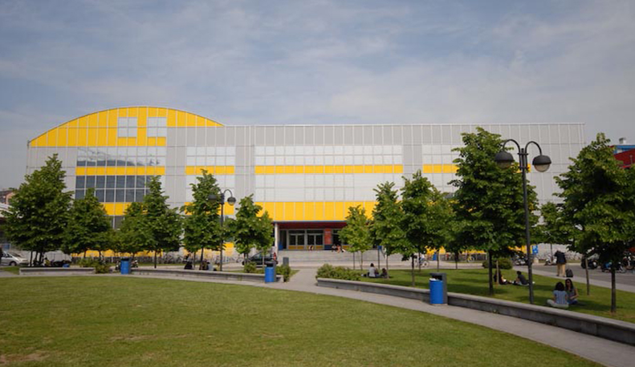
Figure 1. Design campus of the Politecnico di Milano. Source: Polimi Events. (Caption: Calibri italic 9pt)
Captions for the figures should clearly explain what the image illustrates concerning the text. If there are two or more images side-by-side, as shown in Figure 2, you should combine the figures into a single image using image editing software (e.g., Adobe Photoshop) before placing them in the text.
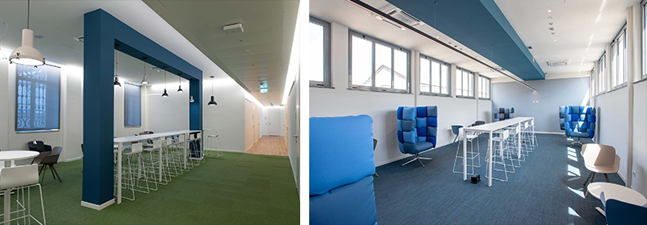
Figure 2. Shared workspaces at the Department of Design of Politecnico di Milano. Source: Department of Design.
We welcome the authors to use colour images.
- Referencing
Please follow the APA reference style for the workshop proposal. For more details, please refer to lessons 16-19 of “Basics of Seventh Edition APA Style.” To format the reference list, use the ‘IASDR Reference’ style. Where possible, include DOI.
Place citations that do not form part of a sentence inside parenthesis. For example: (Jackson, 2019). Show the author(s) name in text and the year within parenthesis for citations that are part of a sentence. For example: Jackson (2019) argues that…
When citing multiple works by the same author(s), separate the publication years with commas. When citing works by different authors in one parenthesis, separate them by semicolons and place them in alphabetical order. For example: (Dillard, 2020; Jackson, 2019).
Give both names when a reference is authored by one or two individuals. For example: (Kushilevitz & Malkin, 2016). For three or more authors, name only the first one followed by et al.. For example: (Duckworth et al., 2019).

References
Examples of references (taken from APA Style):
Journal article with a DOI:
Grady, J. S., Her, M., Moreno, G., Perez, C., & Yelinek, J. (2019). Emotions in storybooks: A comparison of storybooks that represent ethnic and racial groups in the United States. Psychology of Popular Media Culture, 8(3), 207–217. https://doi.org/10.1037/ppm0000185 (Reference list: Calibri 10pt)

Conference proceedings published in a journal:
Duckworth, A. L., Quirk, A., Gallop, R., Hoyle, R. H., Kelly, D. R., & Matthews, M. D. (2019). Cognitive and noncognitive predictors of success. Proceedings of the National Academy of Sciences, USA, 116(47), 23499–23504. https://doi.org/10.1073/pnas.1910510116

Conference proceedings published as a whole book:
Kushilevitz, E., & Malkin, T. (Eds.). (2016). Lecture notes in computer science: Vol. 9562. Theory of cryptography. Springer. https://doi.org/10.1007/978-3-662-49096-9

Conference proceedings published as a book chapter:
Bedenel, A.-L., Jourdan, L., & Biernacki, C. (2019). Probability estimation by an adapted genetic algorithm in web insurance. In R. Battiti, M. Brunato, I. Kotsireas, & P. Pardalos (Eds.), Lecture notes in computer science: Vol. 11353. Learning and intelligent optimization (pp. 225–240). Springer. https://doi.org/10.1007/978-3-030-05348-2_21

Book:
Jackson, L. M. (2019). The psychology of prejudice: From attitudes to social action (2nd ed.). American Psychological Association. https://doi.org/10.1037/0000168-000
Sapolsky, R. M. (2017). Behave: The biology of humans at our best and worst. Penguin Books.
Svendsen, S., & Løber, L. (2020). The big picture/Academic writing: The one-hour guide (3rd digital ed.). Hans Reitzel Forlag. https://thebigpicture-academicwriting.digi.hansreitzel.dk/

Chapter in a book:
Aron, L., Botella, M., & Lubart, T. (2019). Culinary arts: Talent and their development. In R. F. Subotnik, P. Olszewski-Kubilius, & F. C. Worrell (Eds.), The psychology of high performance: Developing human potential into domain-specific talent (pp. 345–359). American Psychological Association. https://doi.org/10.1037/0000120-016
Dillard, J. P. (2020). Currents in the study of persuasion. In M. B. Oliver, A. A. Raney, & J. Bryant (Eds.), Media effects: Advances in theory and research (4th ed., pp. 115–129). Routledge.
Thestrup, K. (2010). To transform, to communicate, to play—The experimenting community in action. In E. Hygum & P. M. Pedersen (Eds.), Early childhood education: Values and practices in Denmark. Hans Reitzels Forlag. https://earlychildhoodeducation.digi.hansreitzel.dk/?id=192
About the Authors: (Author bio title: Calibri bold 10pt)
Panel member’s name: Include a short bio of the author (50-75 words). Use this to provide an overview of the research interest and/or a major achievement. (Author bio text: Calibri 10pt)
Panel member’s name: Include a short bio of the author (50-75 words). Use this to provide an overview of the research interest and/or a major achievement.
Panel member’s name: Include a short bio of the author (50-75 words). Use this to provide an overview of the research interest and/or a major achievement.

