Title (Heading 1: Arial 18pt)
Leave blank for blind peer review Author’s Last Name, Author’s First Name*ª; Second Author’s Last Name, Second Author’s First Name^{b}; Third Author’s Last Name, Third Author’s First Name^{b} (Authors: Calibri 10pt)
ª Leave blank for blind peer review Affiliation Organisation Name, City, Country (Affiliation: Calibri 9pt)
^{b} Leave blank for blind peer review Affiliation Organisation Name, City, Country
* Leave blank for blind peer review The corresponding author e-mail address
This guide provides instructions to format the full paper for the IASDR 2023 congress hosted by the Politecnico di Milano. Please format your full paper exactly as this document is formatted. To reduce your time formatting your submission, you can substitute the content of this template with your own. You can easily find the text styling of this template by searching the embedded styles that contain 'IASDR' in their naming. The full paper should be 4000-6000 words long, excluding the abstract and references. Please do not include the author(s) name in the first submission. The abstract should be up to 250 words and should not contain quotations and references. Submit the full paper to https://iasdr2023.polimi.it for review. (Abstract: Calibri 10pt)
Keywords: paper format; formatting instruction; template; IASDR (maximum 4 keywords, separate each keyword with a semicolon) (Keywords: Calibri bold italic 10pt)
- Introduction (Heading 2: Calibri bold 14pt)
An international review panel will double-blind peer review all the submissions. This review panel will include IASDR-appointed members. After the review period, we will notify all authors of acceptance or rejection via email.
Full papers should be 4000-6000 words long, excluding the abstract and references. Authors should address one of the congress themes available on the website (https://iasdr2023.polimi.it) and report on complete studies or theoretical findings. Authors should demonstrate a high degree of academic scholarship, clearly articulate their research focus, provide a concise synthesis of the research context, describe the methods used to undertake the research, present the research findings, and summarize the contribution to the field. Selection of the papers will base on alignment with the congress sub-themes, originality and significance, rigor, coherence, clarity, and communication.
For the blind peer review, all submissions must be anonymous and must not contain the name(s) of the author(s) or any references to institutions. Before uploading your paper, please ensure to remove these.
To be included in the proceedings, at least one of the authors should register, attend and present at the congress. All accepted and revised submissions must be formatted using this template and submitted to the congress system by the deadline. Please check important dates at https://iasdr2023.polimi.it. (Main text: Calibri 11pt)
- Formatting your full paper submission
To reduce your time formatting your submission, you can substitute the content of this template with your own. You can easily find the text styling of this document by searching the embedded styles that contain 'IASDR' in their naming in the Styles Pane.
The page is an A4 (21cm x 29.7cm) set with a top margin of 2.54 cm, a bottom margin of 2.54 cm, a left margin of 2.54 cm, and a right margin of 2.54 cm.
Please use footnotes instead of endnotes and never use footnotes as a reference list.
- Headings (Heading 3: Calibri bold 12pt)
You can find the Heading styles of this document under the names ‘IASDR Heading 1’, ‘IASDR Heading 2’, ‘IADSR Heading 3’, and ‘IADSR Subheading’. Always add text below the headings (never leave headings under headings).
- Subheadings (Subheading: Calibri 11pt)
If you require another heading level, use the ‘IASDR Subheading’ style. This subheading style has the same styling as that of the document’s text (‘IASDR Main text’).
- Title and authors
Paper titles should have a maximum length of two rows.
When formatting your anonymous submission, leave the placeholders for authors and affiliation as they appear in this template. When preparing your final submission, list all authors in the author’s row. All authors should fill out contact details (name and affiliation) while the first author should fill out name, affiliation, and email.
- Language and style
English is the writing language of the congress. When writing, try using gender-neutral language and avoid difficult technical terms. Before using acronyms for the first time, write the full name.
- Lists
For sequential listings with numbers, use the ‘IASDR Numbered List’ style. For example:
- List item 1 (Numbered list: Calibri 11pt)
- List item 2
- List item 3
For non-sequential listings in bullet points, use the ‘IASDR Bullet List’ style. For example:
- Bullet point 1 (Bullet list: Calibri 11pt)
- Bullet point 2
- Bullet point 3
- Images
Images and figures should have a resolution that supports print and online viewing. We recommend a resolution of 300 ppi and a minimum resolution of 150 ppi. Always place images/figures within the main text body and apply the ‘IASDR Caption’ style to the captions. Images/figures and captions should always align to the left margin and never exceed the column width. Number images/figures sequentially, starting with Figure 1. See Figure 1 for an example.
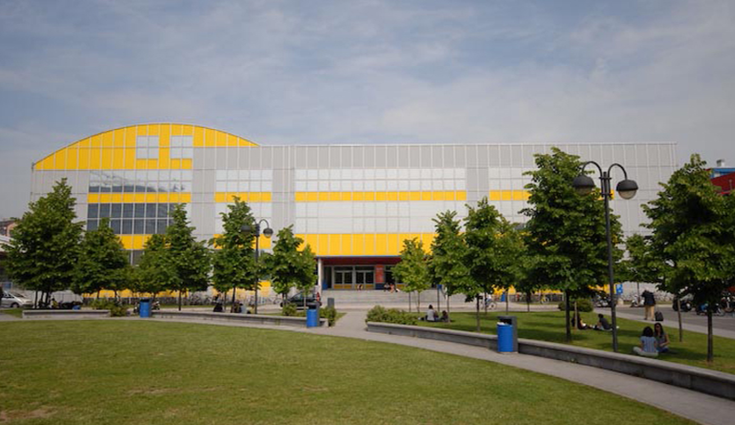
Figure 1. Design campus of the Politecnico di Milano. Source: Polimi Events. (Caption: Calibri italic 9pt)
Captions for the figures should clearly explain what the image illustrates concerning the text. If there are two or more images side-by-side, as shown in Figure 2, you should combine the figures into a single image using image editing software (e.g., Adobe Photoshop) before placing them in the text.
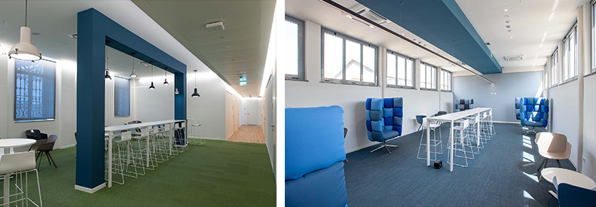
Figure 2. Shared workspaces at the Department of Design of Politecnico di Milano. Source: Department of Design.
We welcome authors to use colour images.
- Tables
Use Word’s table feature to create tables and format them as Table 1. If possible, left-align the text of all columns. Number tables sequentially, starting with Table 1.
See Table 1 for an example.
(Table text: Calibri 10pt) | Column 2 | Column 3 | Column 4
Second Row | Cell one | Cell four | Cell seven
Third Row | Cell two | Cell five | Cell eight
Fourth Row | Cell three | Cell six | Cell nine
Table 1. This is an example of a table that adapts from an external source
If the table is from an external source, indicate the original reference below the table using ‘IADSR Caption’; if the table presents an original work, please insert one empty line below the table by using ‘IASDR Caption’, as shown in Table 2.
Table 2. This is an example of the formatting of an original table (Table title: Calibri 10pt)
(Table text: Calibri 10pt) | Column 2 | Column 3 | Column 4
Second Row | Cell one | Cell four | Cell seven
Third Row | Cell two | Cell five | Cell eight
Fourth Row | Cell three | Cell six | Cell nine

- Referencing
Author(s) should follow the APA reference style for the papers. For more details, please refer to lessons 16-19 of “Basics of Seventh Edition APA Style.” To format the reference list, use the ‘IASDR Reference’ style. Where possible, include DOI.
Place citations that do not form part of a sentence inside parenthesis. For example: (Jackson, 2019). Show the author(s) name in text and the year within parenthesis for citations that are part of a sentence. For example: Jackson (2019) argues that…
When citing multiple works by the same author(s), separate the publication years with commas. When citing works by different authors in one parenthesis, separate them by semicolons and place them in alphabetical order. For example: (Dillard, 2020; Jackson, 2019).
Give both names when a reference is authored by one or two individuals. For example: (Kushilevitz & Malkin, 2016). For three or more authors, name only the first one followed by et al.. For example: (Duckworth et al., 2019).

References
Examples of references (taken from APA Style):
Journal article with a DOI:
Grady, J. S., Her, M., Moreno, G., Perez, C., & Yelinek, J. (2019). Emotions in storybooks: A comparison of storybooks that represent ethnic and racial groups in the United States. Psychology of Popular Media Culture, 8(3), 207–217. https://doi.org/10.1037/ppm0000185 (Reference list: Calibri 10pt)

Conference proceedings published in a journal:
Duckworth, A. L., Quirk, A., Gallop, R., Hoyle, R. H., Kelly, D. R., & Matthews, M. D. (2019). Cognitive and noncognitive predictors of success. Proceedings of the National Academy of Sciences, USA, 116(47), 23499–23504. https://doi.org/10.1073/pnas.1910510116

Conference proceedings published as a whole book:
Kushilevitz, E., & Malkin, T. (Eds.). (2016). Lecture notes in computer science: Vol. 9562. Theory of cryptography. Springer. https://doi.org/10.1007/978-3-662-49096-9

Conference proceedings published as a book chapter:
Bedenel, A.-L., Jourdan, L., & Biernacki, C. (2019). Probability estimation by an adapted genetic algorithm in web insurance. In R. Battiti, M. Brunato, I. Kotsireas, & P. Pardalos (Eds.), Lecture notes in computer science: Vol. 11353. Learning and intelligent optimization (pp. 225–240). Springer. https://doi.org/10.1007/978-3-030-05348-2_21

Book:
Jackson, L. M. (2019). The psychology of prejudice: From attitudes to social action (2nd ed.). American Psychological Association. https://doi.org/10.1037/0000168-000
Sapolsky, R. M. (2017). Behave: The biology of humans at our best and worst. Penguin Books.
Svendsen, S., & Løber, L. (2020). The big picture/Academic writing: The one-hour guide (3rd digital ed.). Hans Reitzel Forlag. https://thebigpicture-academicwriting.digi.hansreitzel.dk/

Chapter in a book:
Aron, L., Botella, M., & Lubart, T. (2019). Culinary arts: Talent and their development. In R. F. Subotnik, P. Olszewski-Kubilius, & F. C. Worrell (Eds.), The psychology of high performance: Developing human potential into domain-specific talent (pp. 345–359). American Psychological Association. https://doi.org/10.1037/0000120-016
Dillard, J. P. (2020). Currents in the study of persuasion. In M. B. Oliver, A. A. Raney, & J. Bryant (Eds.), Media effects: Advances in theory and research (4th ed., pp. 115–129). Routledge.
Thestrup, K. (2010). To transform, to communicate, to play—The experimenting community in action. In E. Hygum & P. M. Pedersen (Eds.), Early childhood education: Values and practices in Denmark. Hans Reitzels Forlag. https://earlychildhoodeducation.digi.hansreitzel.dk/?id=192
About the Authors: (Author bio title: Calibri bold 10pt)
Author’s name: Include a short bio of the author with maximum limit of 40 words. Use this to provide an overview of the research interest and/or a major achievement. (Author bio text: Calibri 10pt) Please leave blank for the anonymous submission.
Author’s name: Include a short bio of the author with maximum limit of 40 words. Use this to provide an overview of the research interest and/or a major achievement. Please leave blank for the anonymous submission.
Author’s name: Include a short bio of the author with maximum limit of 40 words. Use this to provide an overview of the research interest and/or a major achievement. Please leave blank for the anonymous submission.
Acknowledgement: You can use this optional section to acknowledge the support you have had for your research from internal and external funding bodies, participants, colleagues, and others. You have a maximum limit of 100 words. Please leave blank for the anonymous submission.

