Title (Heading 1: Arial 18pt)
Leave blank for blind peer review Author’s Last Name, Author’s First Name (Authors: Calibri 10pt)
Leave blank for blind peer review Affiliation Organisation Name, City, Country (Affiliation: Calibri 9pt)

- Introduction (Heading 2: Calibri bold 14pt)
Doctoral candidates and recent master’s degree graduates wishing to participate in this format must submit a 300-500 word abstract (excluding references) that includes how their research addresses the conference theme—Life-Changing Design.
Authors should write and present their abstracts in English while following the APA publication style for reference lists. Files should be submitted in pdf version following this template.
For the blind peer review, all abstract submissions must be anonymous and must not contain the name of the author or any references to institutions. Before uploading your abstract, please ensure to remove these.
A review panel from the Politecnico di Milano will review and select all the Consortium submissions. After the review period, we will notify all authors of acceptance or rejection via email. We will invite accepted authors to deliver a short talk and will publish their contribution in the conference proceedings.
Please see section 2 for abstract formatting details. (Main text: Calibri 11pt)
- Formatting your abstract submission
To reduce your time formatting your submission, you can substitute the content of this template with your own. You can easily find the text styling of this document by searching the embedded styles that contain 'IASDR' in their naming in the Styles Pane.
The page is an A4 (21cm x 29.7cm) set with a top margin of 2.54 cm, a bottom margin of 2.54 cm, a left margin of 2.54 cm, and a right margin of 2.54 cm.
Please use footnotes instead of endnotes and never use footnotes as a reference list.
- Headings (Heading 3: Calibri bold 12pt)
You can find the Heading styles of this document under the names ‘IASDR Heading 1’, ‘IASDR Heading 2’, ‘IADSR Heading 3’, and ‘IADSR Subheading’. Always add text below the headings (never leave headings under headings).
- Subheadings (Subheading: Calibri 11pt)
If you require another heading level, use the ‘IASDR Subheading’ style. This subheading style has the same styling as that of the document’s text (‘IASDR Main text’).
- Title and authors
Abstract titles should have a maximum length of two rows. When formatting your anonymous submission, leave the placeholders for author and affiliation as they appear in this template.
- Language and style
English is the writing language of the congress. When writing, try using gender-neutral language and avoid difficult technical terms. Before using acronyms for the first time, write the full name.
- Images
Images and figures should have a resolution that supports print and online viewing. We recommend a resolution of 300 ppi and a minimum resolution of 150 ppi. Always place images/figures within the main text body and apply the ‘IASDR Caption’ style to the captions. Images/figures and captions should always align to the left margin and never exceed the column width. Number images/figures sequentially, starting with Figure 1. See Figure 1 for an example.
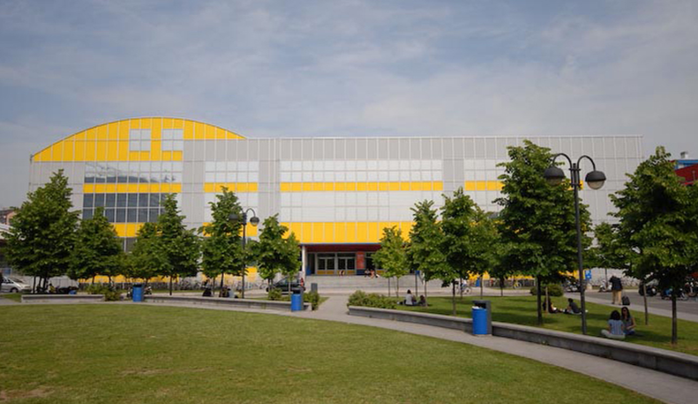
Figure 1. Design campus of the Politecnico di Milano. Source: Polimi Events. (Caption: Calibri italic 9pt)
Captions for the figures should clearly explain what the image illustrates concerning the text. If there are two or more images side-by-side, as shown in Figure 2, you should combine the figures into a single image using image editing software (e.g., Adobe Photoshop) before placing them in the text.
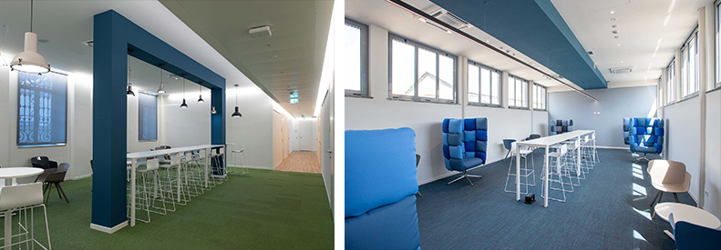
Figure 2. Shared workspaces at the Department of Design of Politecnico di Milano. Source: Department of Design.
We welcome authors to use colour images.
- Referencing
Author(s) should follow the APA reference style for the abstracts. For more details, please refer to lessons 16-19 of “Basics of Seventh Edition APA Style.” To format the reference list, use the ‘IASDR Reference’ style. Where possible, include DOI.
Place citations that do not form part of a sentence inside parenthesis. For example: (Jackson, 2019). Show the author(s) name in text and the year within parenthesis for citations that are part of a sentence. For example: Jackson (2019) argues that…
When citing multiple works by the same author(s), separate the publication years with commas. When citing works by different authors in one parenthesis, separate them by semicolons and place them in alphabetical order. For example: (Dillard, 2020; Jackson, 2019).
Give both names when a reference is authored by one or two individuals. For example: (Kushilevitz & Malkin, 2016). For three or more authors, name only the first one followed by et al.. For example: (Duckworth et al., 2019).

References
Examples of references (taken from APA Style):
Journal article with a DOI:
Grady, J. S., Her, M., Moreno, G., Perez, C., & Yelinek, J. (2019). Emotions in storybooks: A comparison of storybooks that represent ethnic and racial groups in the United States. Psychology of Popular Media Culture, 8(3), 207–217. https://doi.org/10.1037/ppm0000185 (Reference list: Calibri 10pt)

Conference proceedings published in a journal:
Duckworth, A. L., Quirk, A., Gallop, R., Hoyle, R. H., Kelly, D. R., & Matthews, M. D. (2019). Cognitive and noncognitive predictors of success. Proceedings of the National Academy of Sciences, USA, 116(47), 23499–23504. https://doi.org/10.1073/pnas.1910510116

Conference proceedings published as a whole book:
Kushilevitz, E., & Malkin, T. (Eds.). (2016). Lecture notes in computer science: Vol. 9562. Theory of cryptography. Springer. https://doi.org/10.1007/978-3-662-49096-9

Conference proceedings published as a book chapter:
Bedenel, A.-L., Jourdan, L., & Biernacki, C. (2019). Probability estimation by an adapted genetic algorithm in web insurance. In R. Battiti, M. Brunato, I. Kotsireas, & P. Pardalos (Eds.), Lecture notes in computer science: Vol. 11353. Learning and intelligent optimization (pp. 225–240). Springer. https://doi.org/10.1007/978-3-030-05348-2_21

Book:
Jackson, L. M. (2019). The psychology of prejudice: From attitudes to social action (2nd ed.). American Psychological Association. https://doi.org/10.1037/0000168-000
Sapolsky, R. M. (2017). Behave: The biology of humans at our best and worst. Penguin Books.
Svendsen, S., & Løber, L. (2020). The big picture/Academic writing: The one-hour guide (3rd digital ed.). Hans Reitzel Forlag. https://thebigpicture-academicwriting.digi.hansreitzel.dk/

Chapter in a book:
Aron, L., Botella, M., & Lubart, T. (2019). Culinary arts: Talent and their development. In R. F. Subotnik, P. Olszewski-Kubilius, & F. C. Worrell (Eds.), The psychology of high performance: Developing human potential into domain-specific talent (pp. 345–359). American Psychological Association. https://doi.org/10.1037/0000120-016
Dillard, J. P. (2020). Currents in the study of persuasion. In M. B. Oliver, A. A. Raney, & J. Bryant (Eds.), Media effects: Advances in theory and research (4th ed., pp. 115–129). Routledge.
Thestrup, K. (2010). To transform, to communicate, to play—The experimenting community in action. In E. Hygum & P. M. Pedersen (Eds.), Early childhood education: Values and practices in Denmark. Hans Reitzels Forlag. https://earlychildhoodeducation.digi.hansreitzel.dk/?id=192

